姓名
梅琛奥 / Chenao Mei
教育与工作经历
2025 – Present · Southern University of Science and Technology · Automation (B.Eng.)
电子邮箱
12511705@mail.sustech.edu.cn
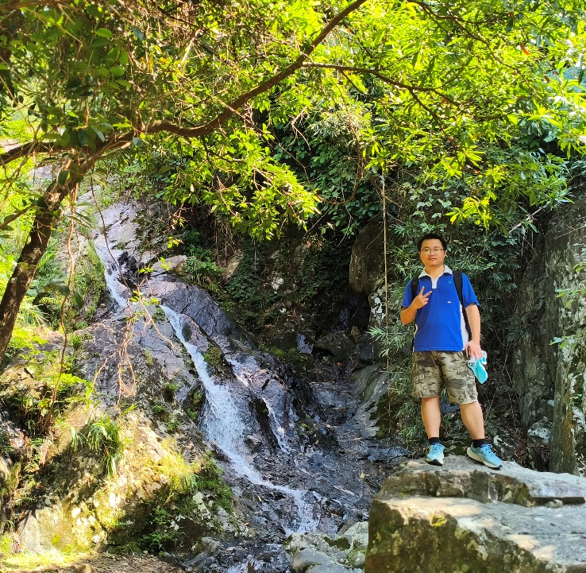
个人照片

研究领域（或感兴趣的研究方向）
Soft robotics; Soft actuators; Mechanical design.
自我介绍
I am a 25th-grade undergraduate student majoring in Automation at SUSTech. I am honored to join Professor Yue's research group for academic studies.
论文发表情况
（留空）

